Greetings from the NH Marathon Committee,
Over the past 32 years the NH Marathon has steadily evolved into a significant annual multi-event for local businesses and organizations. Many of our 800+ runners registered for the marathon, half-marathon, 10K and children’s race bring family members and/or friends with them which turns the event into a weekend stay in the Newfound Lake region. We are actively seeking area businesses that can serve as event sponsors for our 2026 race. These sponsorships are crucial in helping us continue to offer this special event in our backyard.

In addition to strengthening the local economy, the NH Marathon has donated over $500,000 to local organizations that provide critical programs for children in our region. We are pleased to continue to support the Tapply-Thompson Community Center, Circle Program and Mayhew Program in 2026.
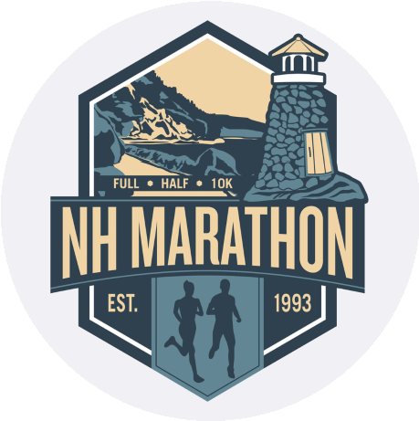
Contact
(603) 744-2713
race@nhmarathon.com
www.nhmarathon.com
Sponsored by the Bristol Recreation Advisory Council
30
North Main St., Bristol, NH
03222
The New Hampshire Marathon

Sponsorship Request

Winter 2026
At Newfound Lake

We invite you to consider joining us as a sponsor and partner for this year’s race being held on Saturday, October 3,
2026. With this letter, we have included information regarding Sponsorship levels and a Sponsorship
Commitment/Pledge Form. We are dedicated to actively promoting every sponsor who helps make this event successful and supports our local children and families. Please return the sponsor pledge form with payment by April 15th to be included in this year’s promotional materials.
Thank you for everything you do to make our community such a great place to live, work & visit! Please contact the Tapply-Thompson Community Center at 744-2713 or email us at race@nhmarathon.com if you have any questions.
With gratitude,
NH Marathon Committee ~ Karen Schaffner, Bob Watson, Carol Huber, Cindy Williams, Erica LaBella, Julaine Gelderman, Angie Knott, Jeff Mattson, John Clayton, Samantha Hooper, Sue Anair-Watts, Wendy Williams, Beth Dever, Dan MacLean, Peter Saliba, Ed Johnson, and Les Dion.

